**Week04 and week05 Assignment Due Oct 02 (30 points)**

**Test assumptions, experimental units, p-values**

Note: This one is a bit longer than previous assignments as it covers 2 weeks of lectures.

Q1 – Q12. Let’s revisit Figure 2b of the SilvestreRoig paper. In the week02 assignment, you plotted frequency histograms and made some guesses about symmetry and skew. You will now do a more detailed exploration of the data distribution of the 4 groups in the figure. Although the adherent and polarized groups are shown on the same graph, the authors really wanted to compare the adherent control to the adherent PDGF-BB and the polarized groups to each other.

Q1. Complete the table below. (3 pts)

N mean SD median skewness

Ctrl Adherent 39 40.9 19.1 37 0.61

PDGF-BB Adherent 35 74.5 50.7 59 1.74

Ctrl Polarized 26 65.7 27.7 64.9 -0.64

PDGF-BB Polarized 28 81.4 13.1 80.4 -0.25

TA’s each answer is worth 0.25 pts.

Q2. From the table above, based on mean and median and skewness, which variable is most likely to have a symmetrical distribution and why? (1 pt)

PDGF-BB Polarized

PDGF-BB Adherent. Mean and median seem to be close and skew is minimal.

Q3. Create individual box plots for each variable. Do the adherent groups side-by-side. So the same for the polarized groups. Be sure to label each graph and the Y-axis. Copy and paste below. (2 pts)

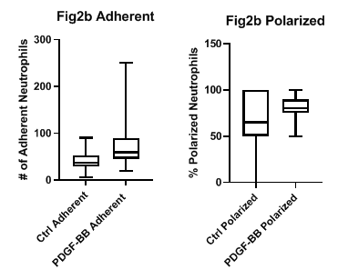

For this part we will specifically ask for boxplot with whiskers or 95% CI.

TA’s each graph is worth 1 pt. Take 0.25 points off each if they do not label the graph and axes.

Q4. Based on the box plots, which group looks to be the least symmetrical and why? (1 pt)

Ctrl Polarized. The median is not in the center of the box and there is no whisker on one side of the box.

Q5. Create a Q-Q plot for each group. Copy the graphs below. (2 pts)

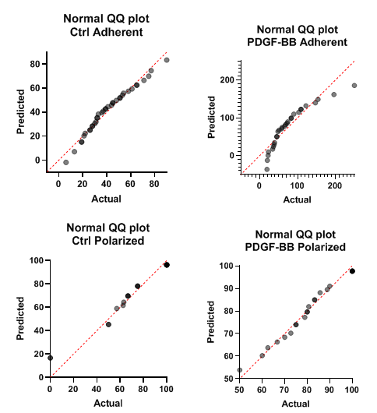

TA’s each graph is worth 0.5 points

Q6. Which of the Q-Q plots demonstrates the least symmetry, just look at the QQ plots? (1 pt)

.

PDGF-BB adherent

Q7. Complete the table below. (2 pts)

Anderson-Darling D’Agostino-Pearson Shapiro-Wilk

Ctrl Adherent Normal Normal Normal

PDGF-BB Adherent Not normal Not normal Not normal

Ctrl Polarized Not normal Normal Not normal

PDGF-BB Polarized Normal Normal Normal

TA’s each answer is worth 0.25 points

Q8. Do you think that doing a normality test is appropriate on the data and why or why not (hint: sample size)? (1 pt)

Yes, sample sizes are between 20-50.

Q9. What type of data transformation would you do on each of the groups? (3 pts)

Group Type of transformation Why

Ctrl Adherent Square root Count data with right skew

PDGF-BB Adherent Square root Count data with right skew

Ctrl Polarized Power Continuous data with Left skew

PDGF-BB Polarized Power Left skew

TA’s each answer is worth 0.5 points

Q10. You want to determine if the number of adherent neutrophils are different between the Ctrl Adherent and PDGF-BB Adherent groups. You would like to do a parametric independent (unpaired) t-test that has the assumptions the data are: normally distributed (symmetrical), homoscedastic, and independent. I will tell that from the study design, the data are independent. Do you think the data are symmetrical (in both groups) and are homoscedastic (between groups)? Why or why not? (2 pts)

No they do not seem to meet the assumption of normality. Both data sets are left skewed, especially the PDGR-BB group. Nor do they meet the assumption of homoscedasticity as the SD are different (50.7/19/1 = 2.65 which is >2)

Q11. Even if you concluded the data do not meet the assumptions of an independent t-test in Q10, for this example, we will assume that that they do. State the null hypothesis for the t-test and two-sided alternate hypothesis. In statistical context(2 pts)

Null: there is no difference in means. Use the statistical context, the parameter and the estimators

Alternate: the means are different.

Q12. You perform the t-test and find that the p=0.001. What do you conclude about the differences between the number of neutrophils between the two adherent groups? (1 pt)

We reject the null hypothesis and accept the alternative. The means are different.

Q13-Q15. In the Week03 assignment, you did box plots of the Macrophage vs. SMC groups. The data for each group is highly skewed, but there is no evidence of heteroscedasticity as the standard deviations for both groups are almost the same. The mean, median, SD, and skewness values are shown below:

Describe which transformation used, if you set up your own function in Graphpad, explain it.

Macrophage SMC

Mean 12.97 9.48

Median 9.87 5.75

SD 10.44 10.92

Skewness 1.56 1.92

Q13. Apply an appropriate data transformation and complete the table below (Data to two decimal points; 2 pts)

Macrophage SMC

Mean 2.32 1.83

Median 2.39 1.91

SD 0.83 1.06

Skewness -0.64 -0.02

Transformation used ____________________ I did Ln(Y+1)

If you are using log10, just see the result below.

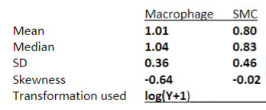

TAs 0.25 points for each answer. If they do a different transformation and the data values are correct for that transformation, take off 1point.

Q14. Plot the transformed data using box plots with . Copy the box plots of the transformed data below. You can show them on the same plot. (1 pt)

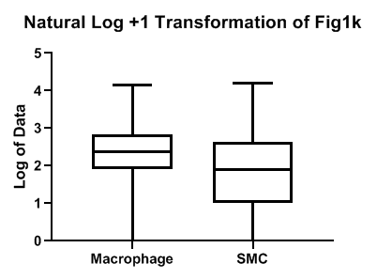

Q15. Do you think your transformation worked (i.e., the data are more symmetrical)? State all the evidence for yes or no. (2 pts) answer about the what you get from the table and the boxplot with whiskers.

Yes the LN(Y+1) transformation seemed to work.

From the table we see, The means and medians for each group are similar and skewness level is less, although skewness is still moderate for the macrophage group.

From the boxplot: The box plots also show more symmetry with the medians near the center of the box and the whiskers are more equal in length.

TA’s, since asked them to plot box plots, they need to say something about them in their answer. If they don’t, take off 0.5 points. If they don’t mention the mean, median closeness of skewness, take of 0.5 points.

Q16a-d. An experiment was done where cells from the same breast cancer cell line were injected into two mammary pads (one on the right side, one on the left side) of each of 46 mice. The mice were randomized into either placebo or treatment group. The mice were studied for four weeks. At the end of the 4 week period, the volume for each tumor in each animal was measured using calipers. Total tumor burden was calculated as the sum of volumes of the tumors on the right and left sides.

Q16a. What is the total n for this experiment? (1 pt) 46

Q16b. What is the experimental unit? (1 pt) The mouse

Q16c. What is the observational unit? (1 pt) The tumor

Q16d. What is the statistical unit? (1 pt) The mouse, the sum of tumor.